**Practical No:01**

**Informal introduction to programming, algorithms and data structures**

Computer programs (or software) are what make computers work. Without software, modern computers are just complicated machines for turning electricity into heat. It’s software on your computer that runs your operating system, browser, email, games, movie player – just about everything.

Programming is a creative task: there is no right or wrong way to solve a problem, in the same way that there is no right or wrong way to paint a picture. There are choices to be made, and one way may seem better than another, but that doesn’t mean the other is wrong! With the right skills and experience, a programmer can craft software to solve an unlimited number of problems – from telling you when your next train will arrive to playing your favourite music. The possibilities are constrained only by your imagination. That’s why I love programming.

Algorithm is a step-by-step procedure, which defines a set of instructions to be executed in a certain order to get the desired output. Algorithms are generally created independent of underlying languages, i.e. an algorithm can be implemented in more than one programming language.

From the data structure point of view, following are some important categories of algorithms −

* **Search** − Algorithm to search an item in a data structure.
* **Sort** − Algorithm to sort items in a certain order.
* **Insert** − Algorithm to insert item in a data structure.
* **Update** − Algorithm to update an existing item in a data structure.
* **Delete** − Algorithm to delete an existing item from a data structure.

**Data Structure** is a way to store and organize data so that it can be used efficiently. Data Structure such as Array, Pointer, Structure, Linked List, Stack, Queue, Graph, Searching, Sorting, Programs, etc.

**What is Data Structure?**

The data structure name indicates itself that organizing the data in memory. There are many ways of organizing the data in the memory as we have already seen one of the data structures, i.e., array in C language. Array is a collection of memory elements in which data is stored sequentially, i.e., one after another. In other words, we can say that array stores the elements in a continuous manner. This organization of data is done with the help of an array of data structures. There are also other ways to organize the data in memory. Let's see the different types of data structures.

The data structure is not any programming language like C, C++, java, etc. It is a set of algorithms that we can use in any programming language to structure the data in the memory.

To structure the data in memory, 'n' number of algorithms were proposed, and all these algorithms are known as Abstract data types. These abstract data types are the set of rules.

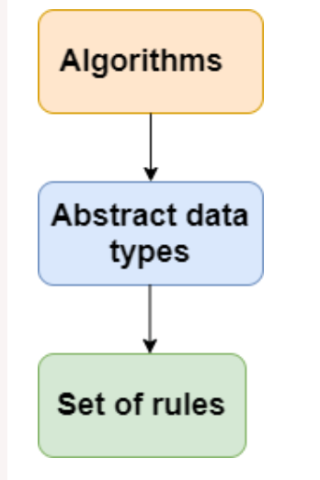

**History of Python** Python is a widely used general-purpose, high-level programming language. It was initially designed by Guido van Rossum in 1991 and developed by Python Software Foundation. It was mainly developed for emphasis on code readability, and its syntax allows programmers to express concepts in fewer lines of code.

What is Python?

Python is a popular programming language. It was created by Guido van Rossum, and released in 1991. It is used for:

• web development (server-side),

• software development,

• Handle big data and perform complex mathematics.

• System scripting.

• Rapid prototyping, or for production-ready software development.

• Connect to database systems. It can also read and modify files.

**Features of Python**

Python provides lots of features that are listed below.

**1) Easy to Learn and Use**

Python is easy to learn and use. It is developer-friendly and high level programming

language.

**2) Expressive Language**

Python language is more expressive means that it is more understandable and

readable.

**3) Interpreted Language**

Python is an interpreted language i.e. interpreter executes the code line by line at a

time. This makes debugging easy and thus suitable for beginners.

**4) Cross-platform Language**

Python can run equally on different platforms such as Windows, Linux, Unix and

Macintosh etc. So, we can say that Python is a portable language.

**5) Free and Open Source**

Python language is freely available at official web address. The source-code is also

available. Therefore it is open source.

**6) Object-Oriented Language**

Python supports object oriented language and concepts of classes and objects come

into existence.

**7) Python is portable and Extensible**

A lot of cross-language operations can be performed easily on Python because of its

portable and extensible nature.

**8) Large Standard Library**

Python has a large and broad library and provides rich set of module and functions for

rapid application development.

**9) GUI Programming Support**

Graphical user interfaces can be developed using Python.

**10) Integrated**

It can be easily integrated with languages like C, C++, JAVA etc.

**11) Python is Easy To Use**

Nobody likes excessively complicated things and so the ease of using Python is one of

the main reasons why it is so popular for Machine Learning. It is simple with an easily

readable syntax and that makes it well-loved by both seasoned developers and

experimental students

**12) Python has multiple Libraries and Frameworks**

Python is already quite popular and consequently, it has hundreds of different libraries

and frameworks that can be used by developers.

**13) Python has Community and Corporate Support**

Python has been around since 1990 and that is ample time to create a supportive

Community

**Result: We have successfully studied Informal introduction to programming, algorithms and data structures**